Unit 5: Scale Representations

Lesson 2: 3-Dimensional Drawings

Assignment

/5 1. Draw a hexagon in the upper section of the space below. Choose a point of perspective in the lower right and create a one-point perspective drawing using your own vanishing point.

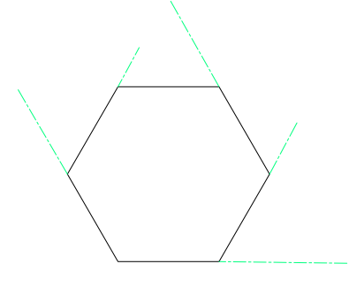

/4 2. With a pencil and an eraser, draw the horizon line, the vanishing point, and the converging lines. Label all the parts you draw in.

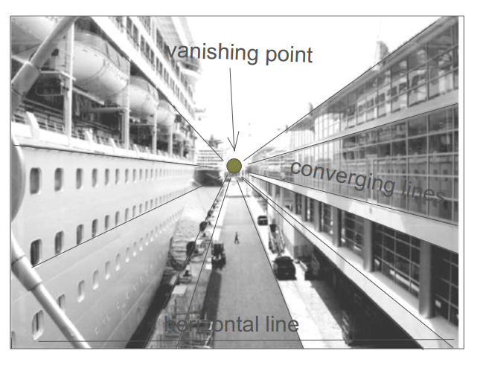

/5 3. Given the top, front and right-side views of the object shown, create the isometric drawing of the object on the dot paper provided.

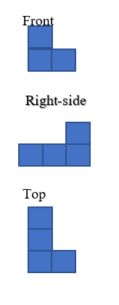


/6 4.

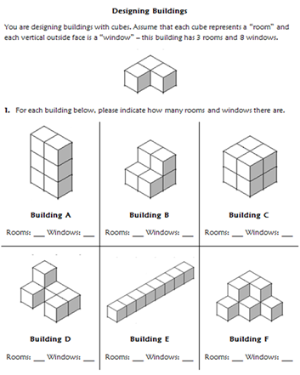

Building | Rooms | Windows
A | 6 | 18
B | 6 | 14
C | 8 | 16
D | 6 | 16
E | 8 | 18
F | 6 | 20

/4 5. Match each top view with the correct isometric drawing.
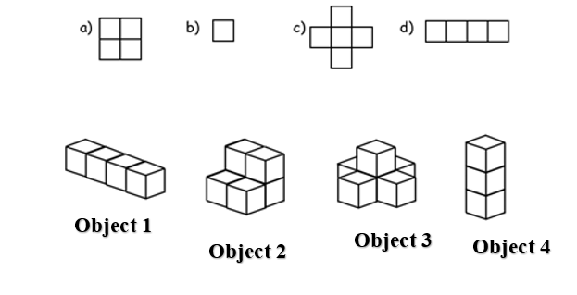

Object | Isometric Drawing
1 | d
2 | a
3 | c
4 | b

/6 6. Draw the front view, the right-side view, and the top view of the stacked cube structure below.

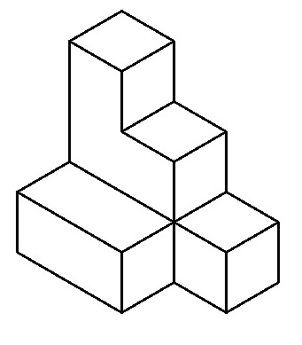
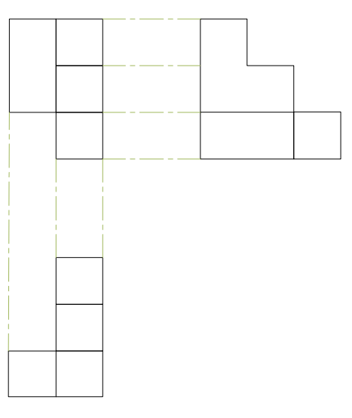
/2
7. What does the following exploded view diagram represent? Draw a sketch of the object.
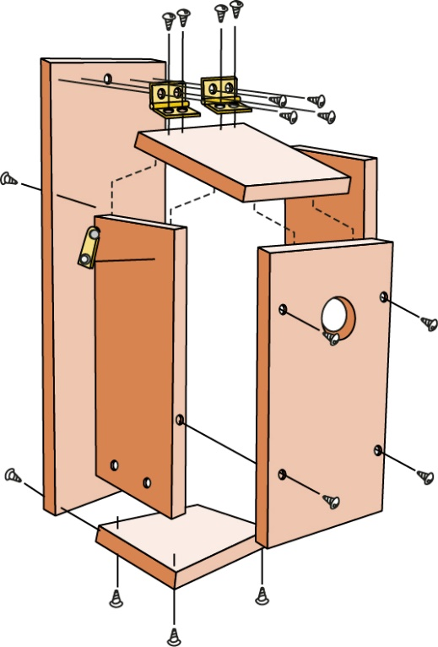

The sketch is as follows;
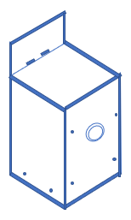

/10 8. Some career areas that use exploded view diagrams are:

- engineering
- automotive parts technology
- design
- furniture construction
- assembly
- mechanics
- repair/service
- patents
- architecture
- landscaping
- advertising
- training and education
- graphic arts
- anatomy

Research a career area that interests you and explore how the career involves exploded view diagrams. Select and copy one exploded view diagram. Does this diagram contain the features of exploded views described in this lesson? Explain. Was this exploded view diagram drawn to scale? How do you know? Determine the scale factor.

In the engineering, there are systems that involves a lot of subsystems that have numerous components. The drawn assembly has to be exploded so that those involved in fabrication can have clear image of every part in the system.

Below is the selected exploded diagram.
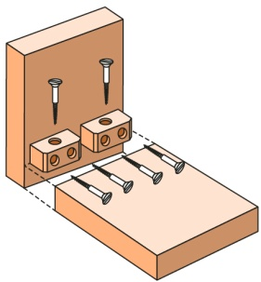
Yes, the diagram has features described in the lessons. For instance, each component has a clear indication which other part they will mate with or flush face with. There diagram is drawn to scale. This was indicated from the section it was obtained from. The scale factor is 1:4.

/2 9. Below is an exploded view diagram of how to brace two pieces of wood together. The screws that are used to brace the wood have a length of 3 in. If the scale factor is 1:4 (model: original), what would be the length of the screws in the exploded diagram?
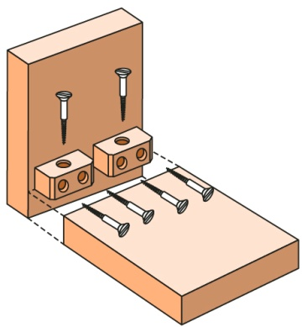
The length of screw on the exploded diagram

L = $\frac{1}{4}*3$
= 0.75 inch

/5 10. Draw an exploded view diagram of the shelving system below.

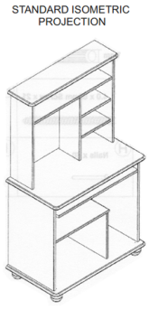
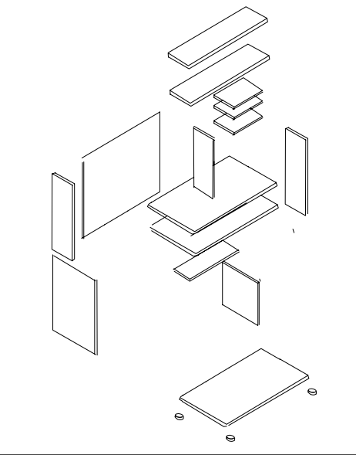

/2 11. What does the following exploded view diagram represent? Draw a sketch of the object.

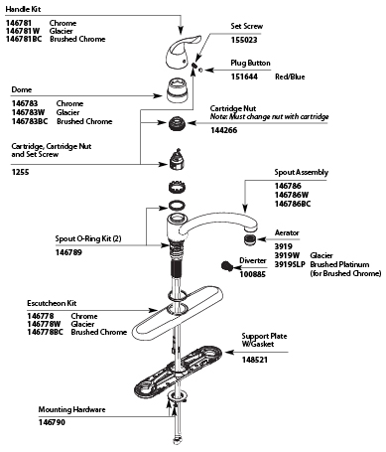

The diagram is as follows;

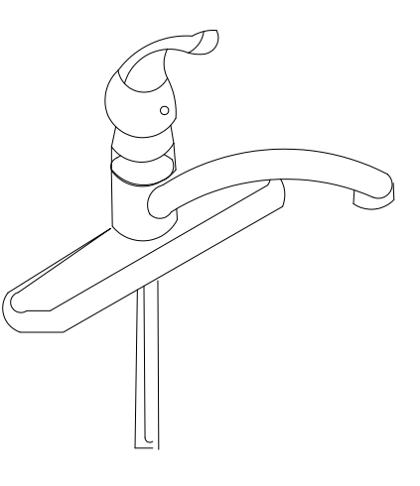

/3 12. Using the numbers only once, arrange the numbers 1, 5, 6, 10, 50, and 60 in the circles so that the numbers in each side of the triangle multiply to give 300.
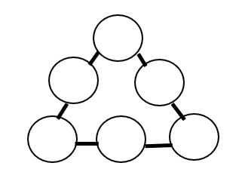
1

60
50

10

5
6

Assignment Grade: /54

